Living Water Network Inc
Atlanta Financial Center
3343 Peachtree Rd NE, Ste 145 PMB 2806
Atlanta, GA 30326
April 20th, 2025
Internal Revenue Service
Exempt Organizations Division
PO BOX 2508, Room 6-403
Cincinnati, OH 45201
Subject: Request for Name Change Update in IRS Records
Dear Sir/Madam,
I hope this letter finds you well. I am writing to inform you of a recent name change for our organization. Please update your records to reflect the new name of our organization as Living Water Network Inc.
For your reference, the Employer Identification Number (EIN) for our organization is 93-1859873, and the previous name of our organization was Living Hydatos Ministries Inc.
If you require any additional documentation or information to process this update, please feel free to contact me directly.
Thank you for your attention to this matter. Should you have any questions or need further clarification, please do not hesitate to contact me.
Sincerely,
Omar Fandino
Founder/CEO
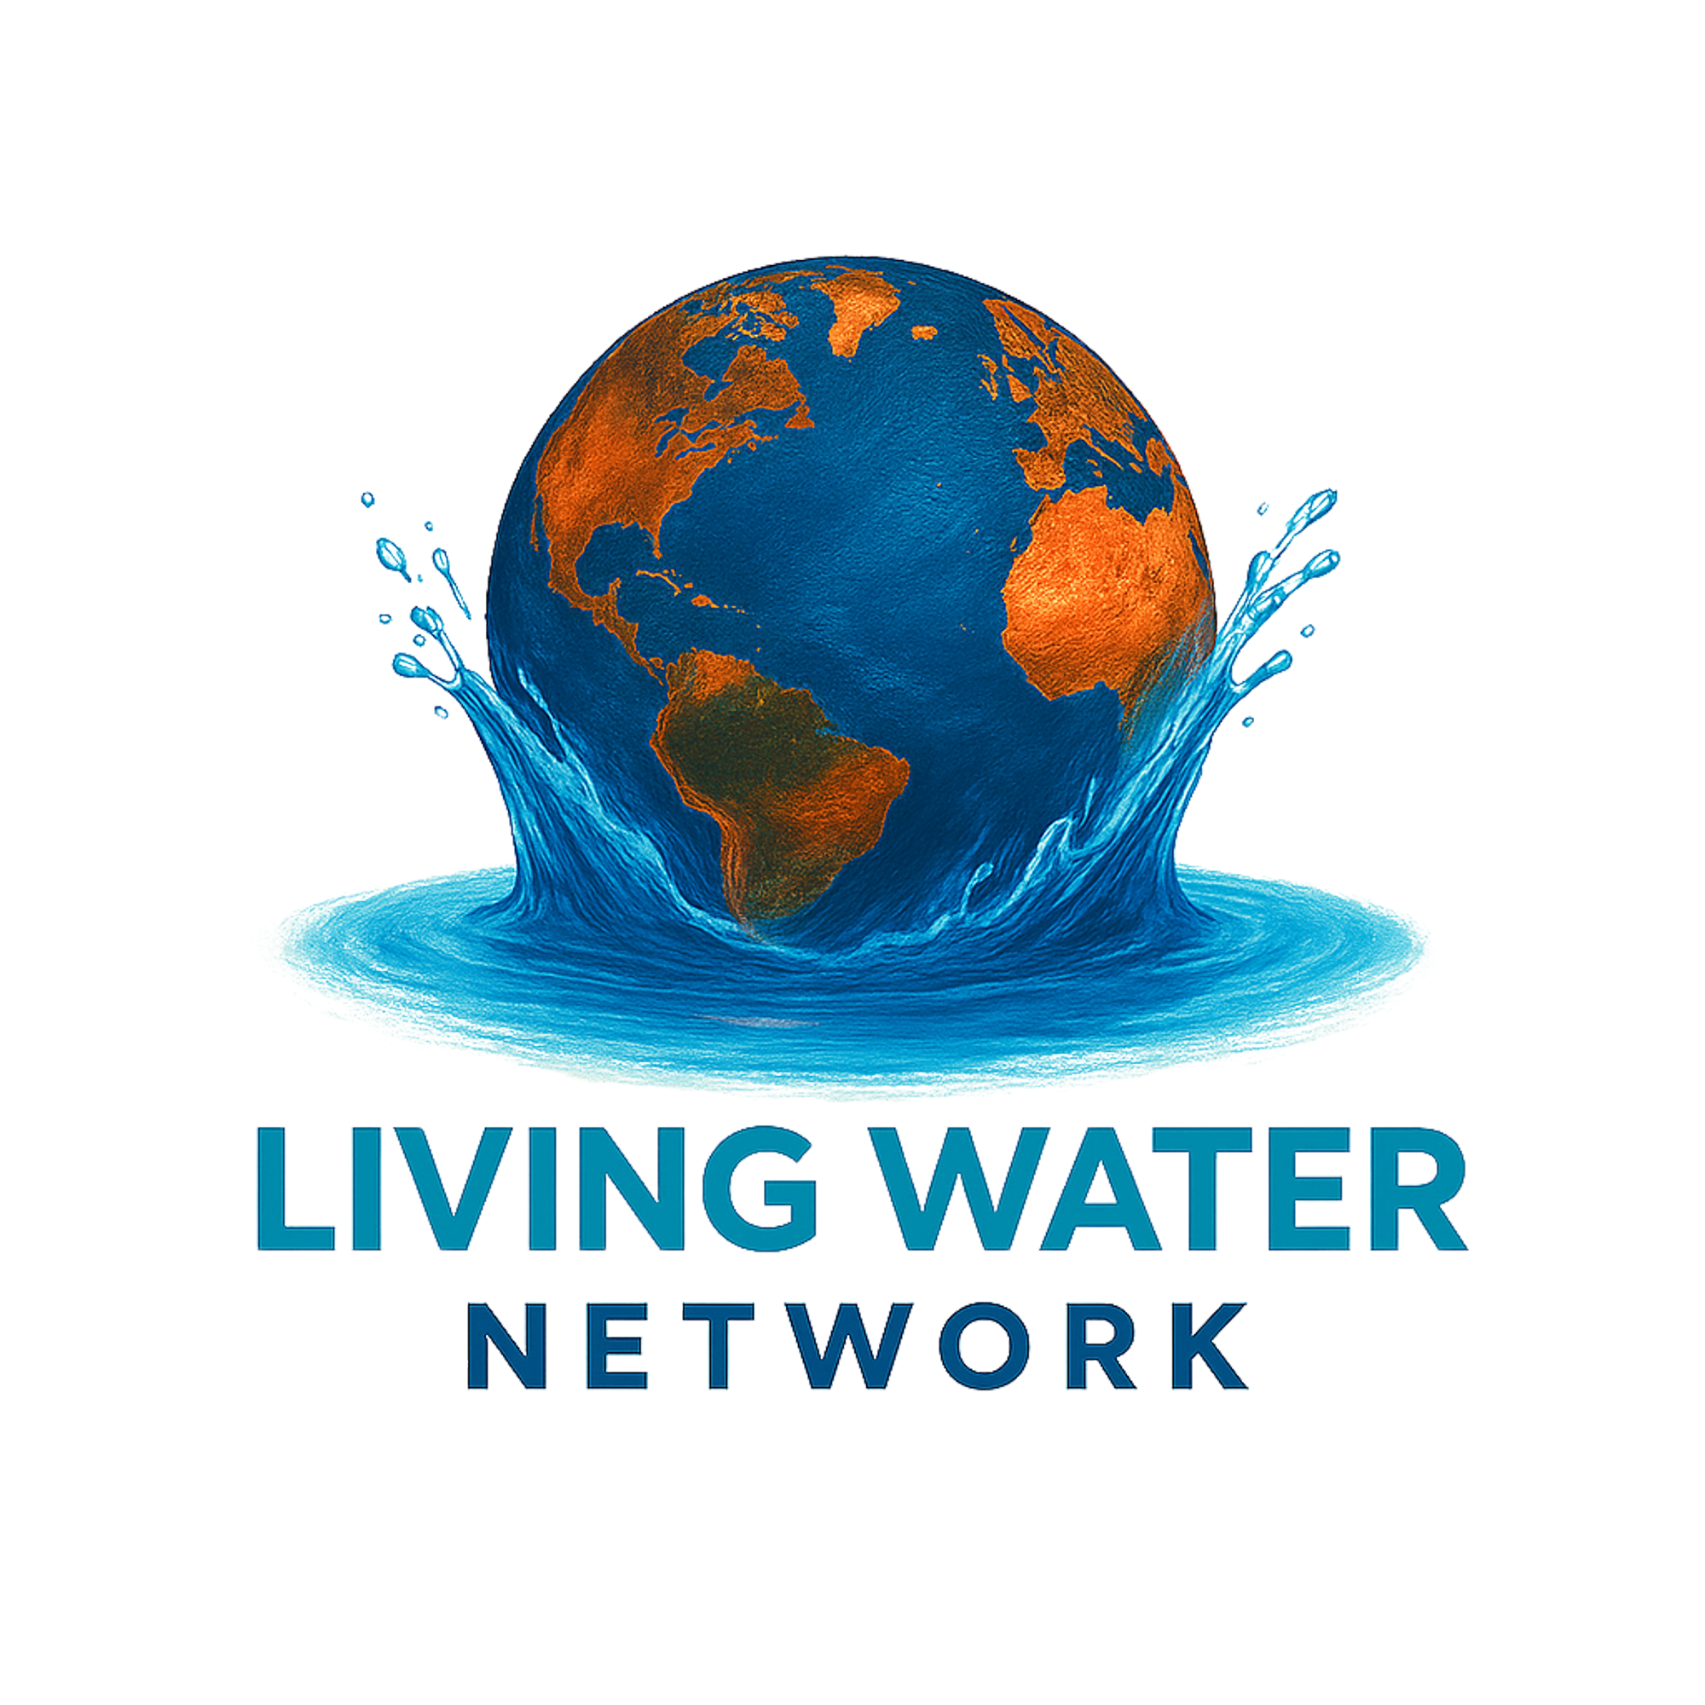
Email: Ofandino@lwnetwork.org
Phone: 470-475-9123

